TURNIGY
LiPo
ESC
ESC
ESC

ESC
10K
20K
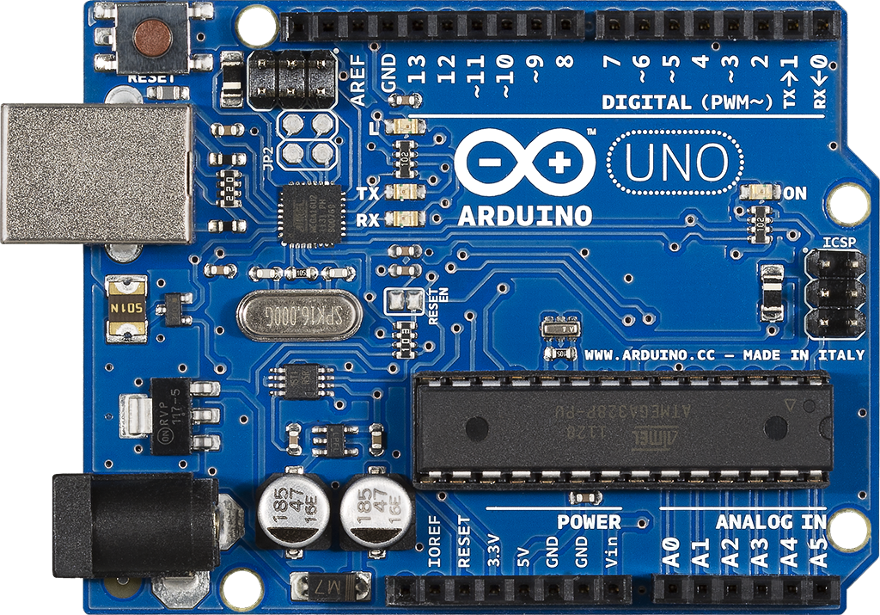

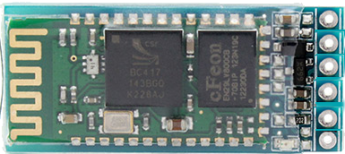
GND
3.3
5.0
TXD
RXD
KEY
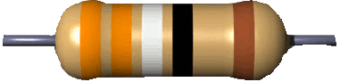
VCC_IN
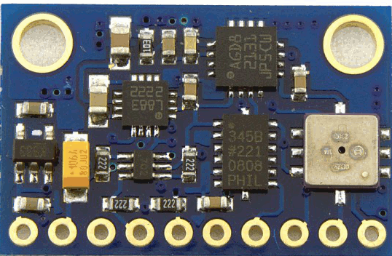
VCC_3.3V
GND
SCL
SDA
M_DRDY
A_INT1
T_INT1
P_XCLR
P_EOC

